"The Art of War Quotes." By Sun Tzu. GoodReads, 2013.

By Lindsey Goes,

Period 2,

Dec. 17, 2013

SUPPLIES

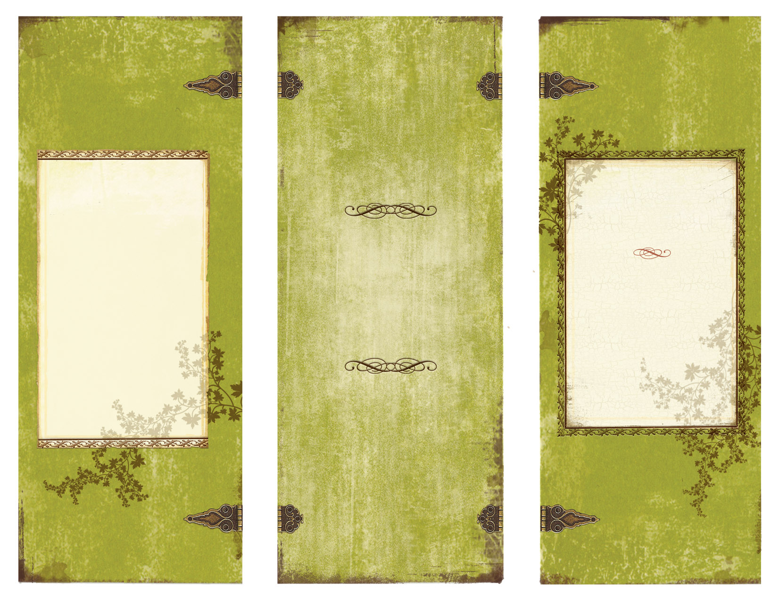

"Chariots in Warfare." *Total War History*. N.p., 01 Sept. 2006.

Graham, William A., and Donald Kagan. "The Eastern Zhou." The Heritage of World Civilizations. By Albert M. Craig. Vol. 1. Upper Saddle River: Prentice Hall, 2002. 25-27.

Hays, Jeffrey. “Facts and Details.” *ZHOU (CHOU) DYNASTY (110-221 B.C.)* N.p., 2008.

Roberts, Stephen. “The Chinese War Chariot.” *Karwansaray Publishers.* 15 Sept. 2013.

The Zhou Dynasty: How to Properly Hack One’s Enemies to Pieces

* As much infantry as possible
* Chariots galore
* One driver, one rongyou, and at least one archer per chariot.
* A “ge” or “dagger-axe,” one for each rongyou. (It’s like a halberd, except the blades were on opposite ends.)
* Armor and shields for everyone, including the horses.
* MONEY to finance all of the above.

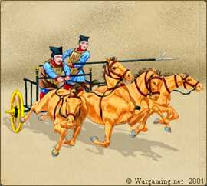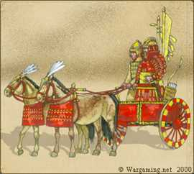

Here’s the usual spread out. You have “x” sections of infantry (as many as you can manage). Plus, you have 100 chariots per section. There are three people to a chariot; one driver, one rongyou, and one archer.

The driver, or charioteer, makes sure the chariot doesn’t tip over. This is important for obvious reasons, but not as easy as you may think. Though faster, the Zhou chariots was just as non-maneuverable as their predecessors. Good for charging, not so good for turning around.

Because the audience has been scratching their heads all this time, a rongyou is the chariot’s close defense, stabbing at the enemy when they get too close with their ge. Makes a lot more sense, huh?

The archer’s purpose is long-range attack. They make the first move, as will be explained later. Because of the increased width of the chariot, more than one archer could be riding in a chariot at a time, so you have almost double the attacking power.

Where Things Get Interesting

“Strategy without tactics is the slowest route to victory. Tactics without strategy is the noise before defeat.”

― Sun Tzu, The Art of War

Because of the fact the Zhou didn’t believe in sneak attacks (sorry, Green Mountain Boys), all battles were scheduled. Also, chariots can’t operate efficiently unless you have level ground, so the battlefields had to be plowed beforehand.

The battle started with an exchange of arrows, each side hoping to subtract a significant number of the other. This is where two archers per chariot comes in handy.

After the armies collide, most of the fighting is done by the infantry, but the chariots have a bit of fun. Well, the Zhou ones, anyway. They were notorious for helping an enemy with their chariot and then tearing them to tiny pieces. By this way, and a few other little tricks that can be read in “The Art of War”, the Zhou won.

In the Zhou dynasty, chariots were extremely popular. So, naturally, some back ground knowledge would be helpful.

The traditional Chinese war chariot is two-wheeled, and pulled by two horses. It was built for strength and stability, not maneuverability.

The Chinese war chariot, as modified by the Zhou, was lightweight, and built for speed. The draw-pole was attached, making it easier for the horses to do their job, which in turn increased efficiency and speed. The physical width of the chariot was doubled, so the soldiers riding in it had more room to move.

Unfortunately, this model is not very sturdy. It could carry its soldiers, the armor they were wearing, the weapons they were carrying, and… that’s about it. No cargo-carrying for these chariots. In other words, invest in wagons.

That’s it for Chariot 101; now onto the human part of the equation.

Chariot 101

